Problem understanding

Design and implement a system that helps users find the shortest path between two locations inside a college campus by modeling the campus as a matrix/grid and applying pathfinding algorithms.

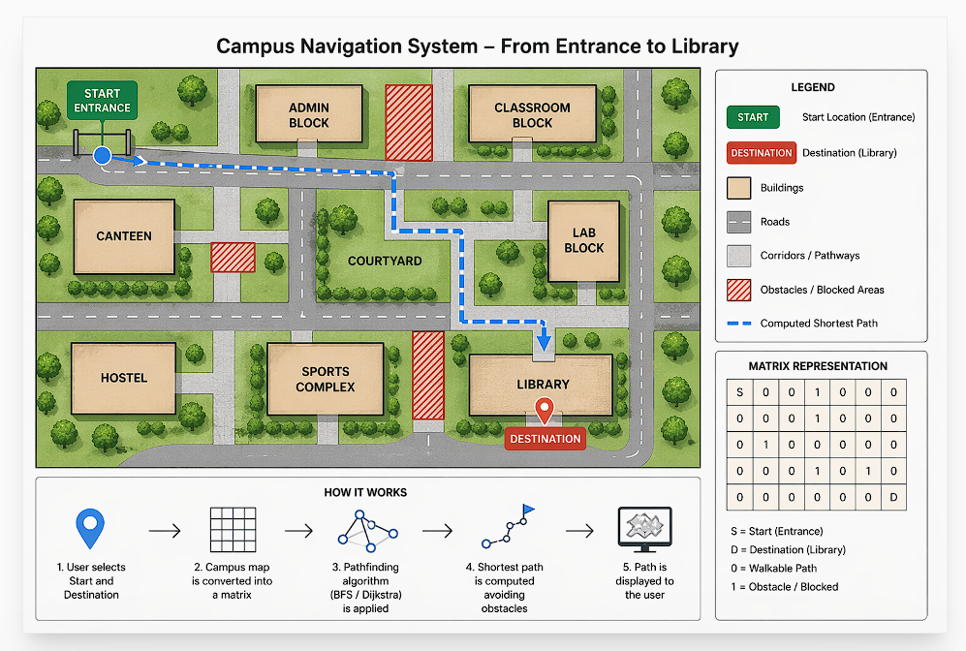

The challenge:

Campus layout is complex
Some paths are blocked or restricted
User needs the shortest or fastest route

Your system should:

Represent campus as a matrix (grid)
Take input:
Start location
Destination
Compute the optimal path
Display the path to the user

Objectives of the project

Help users navigate campus efficiently
Demonstrate matrix-based problem solving
Implement real-world pathfinding logic

Functional Requirements

Your system should:

1. Input
Accept start and destination
Load campus grid

2. Processing
Traverse matrix
Avoid obstacles
Compute shortest path

3. Output
Show path (text or visual)
Indicate if no path exists

Scope (important for SRS)

In Scope:
Grid-based navigation
Shortest path computation
Basic visualization

Out of Scope (for now):
GPS integration
Real-time tracking
Large-scale maps
Real-world relevance

This project simulates:
Google Maps (simplified)
Indoor navigation systems
Robot navigation

